- Weather:
# Load libraries library(scatterplot3d) library(plotly)
# Create dataset
date <- as.Date(c('2023-01-01','2023-01-02','2023-01-03','2023-01-04','2023-01-05'))
temperature <- c(10, 12, 8, 15, 14)
humidity <- c(75, 70, 80, 65, 72)
wind_speed <- c(15, 12, 18, 20, 16)
df <- data.frame(date, temperature, humidity, wind_speed) # 1.Temperature, Humidity & Wind Speed over Time
plot(df$date, df$temperature, type="o", col="red", ylim=c(0,20),
xlab="Date", ylab="Values", main="Temperature, Humidity & Wind Speed") lines(df$date, df$humidity/5, type="o", col="blue")
lines(df$date, df$wind_speed, type="o", col="green")
legend("topright", legend=c("Temperature","Humidity/5","Wind Speed"), col=c("red","blue","green"), lty=1, pch=1)
# 2. 3D Scatter
scatterplot3d(df$humidity, df$wind_speed, df$temperature, color="purple", pch=19,
xlab="Humidity (%)", ylab="Wind Speed (km/h)", zlab="Temperature (°C)", main="3D Scatter: Temp vs Humidity & Wind Speed")
# 3. Correlation Matrix print("Correlation Matrix:") print(cor(df[,2:4]))
# 4. 3D Surface Plot (interactive)
plot_ly(df, x=~humidity, y=~wind_speed, z=~temperature, type="surface", colors = colorRamp(c("skyblue","orange","red"))) %>%
layout(title="3D Surface: Temperature vs Humidity & Wind Speed", scene = list(xaxis=list(title="Humidity (%)"),
yaxis=list(title="Wind Speed (km/h)"), zaxis=list(title="Temperature (°C)")))

# 5. Compare Temperature vs Humidity & Wind Speed par(mfrow=c(1,2))
scatterplot3d(df$humidity, 1:5, df$temperature, color="blue", pch=19,
xlab="Humidity", ylab="Day Index", zlab="Temp (°C)", main="Temp vs Humidity") scatterplot3d(df$wind_speed, 1:5, df$temperature, color="red", pch=19,
xlab="Wind Speed", ylab="Day Index", zlab="Temp (°C)", main="Temp vs Wind
Speed") output:
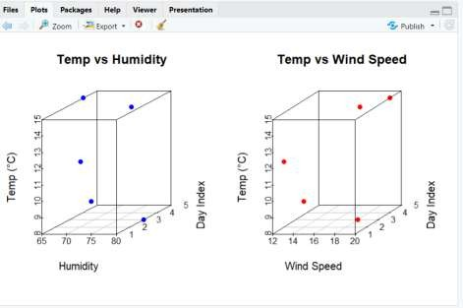
- Financial Market Data:

library(scatterplot3d) library(plotly)
date <- as.Date(c('2023-01-01','2023-01-02','2023-01-03','2023-01-04','2023-01-05'))
stock_price <- c(100, 102, 98, 105, 108)
volume_traded <- c(2.5, 3.0, 2.2, 2.8, 3.5)
market_cap <- c(500, 510, 490, 525, 540)
df <- data.frame(date, stock_price, volume_traded, market_cap) print(df)

# 1. Relationship between Stock Price, Volume, and Market Cap plot(df$date, df$stock_price, type="o", col="red", ylim=c(90,120),
xlab="Date", ylab="Values", main="Stock Price, Volume & Market Cap") lines(df$date, df$volume_traded*30, type="o", col="blue") # scaled for visibility lines(df$date, df$market_cap/10, type="o", col="green")
legend("topleft", legend=c("Stock Price","Volume*30","Market Cap/10"), col=c("red","blue","green"), lty=1, pch=1)

# 2. 3D Scatter Plot
scatterplot3d(df$volume_traded, df$market_cap, df$stock_price,

color="purple", pch=19,
xlab="Volume Traded (millions)", ylab="Market Cap ($)", zlab="Stock Price ($)", main="3D Scatter: Stock Price vs Volume & Market Cap")

# 3. Check for clustering/outliers (via correlation + print summary) print("Correlation Matrix:")
print(cor(df[,2:4])) print("Summary:") print(summary(df))

# 4. 3D Surface Plot — Market Cap vs Stock Price & Volume
plot_ly(df, x=~stock_price, y=~volume_traded, z=~market_cap, type="surface", colors=colorRamp(c("skyblue","orange","red"))) %>%
layout(title="3D Surface: Market Cap vs Stock Price & Volume", scene=list(xaxis=list(title="Stock Price ($)"),
yaxis=list(title="Volume Traded (millions)"), zaxis=list(title="Market Cap ($)")))

# 5. Compare 3D Plots — Stock Price vs Volume & Market Cap par(mfrow=c(1,2))
scatterplot3d(df$volume_traded, 1:5, df$stock_price, color="blue", pch=19, xlab="Volume Traded", ylab="Day Index", zlab="Stock Price ($)", main="Stock Price vs Volume")
scatterplot3d(df$market_cap, 1:5, df$stock_price, color="red", pch=19, xlab="Market Cap ($)", ylab="Day Index", zlab="Stock Price ($)", main="Stock Price vs Market Cap")

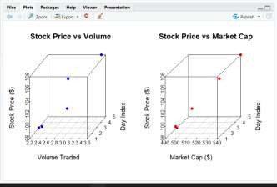
output:

- Consumer Survey Data:

library(scatterplot3d) library(plotly)
product <- c("A", "B", "C", "D", "E") price <- c(50, 70, 60, 45, 55)
rating <- c(4.2, 3.8, 4.0, 4.5, 3.9)
age_group <- c("25-35", "35-45", "18-25", "45-55", "25-35")
# Convert age group to numeric midpoints (for plotting)

age_mid <- c(30, 40, 21, 50, 30)
df <- data.frame(product, price, rating, age_group, age_mid) print(df)

# 1. Ratings vs Price and Age Group
plot(df$price, df$rating, type="o", col="blue", pch=19, xlab="Product Price ($)", ylab="Rating (out of 5)", main="Product Rating vs Price and Age Group")
text(df$price, df$rating+0.05, df$age_group, cex=0.8) grid()

# 2. 3D Scatter Plot
scatterplot3d(df$price, df$age_mid, df$rating, color="purple", pch=19,
xlab="Price ($)", ylab="Age (midpoint)", zlab="Rating (out of 5)", main="3D Scatter: Rating vs Price & Age Group")

# 3. Correlation between Price, Age, and Rating print("Correlation Matrix:") print(cor(df[,c("price","age_mid","rating")]))

# 4. 3D Surface Plot — Rating vs Price & Age Group plot_ly(df, x=~price, y=~age_mid, z=~rating, type="surface",
colors=colorRamp(c("skyblue","orange","red"))) %>% layout(title="3D Surface: Rating vs Price & Age Group",
scene=list(xaxis=list(title="Price ($)"), yaxis=list(title="Age (midpoint)"), zaxis=list(title="Rating (out of 5)")))

# 5. Compare 3D Plots — Rating vs Price & Rating vs Age par(mfrow=c(1,2))
scatterplot3d(df$price, 1:5, df$rating, color="blue", pch=19, xlab="Price ($)", ylab="Product Index", zlab="Rating", main="Rating vs Price")
scatterplot3d(df$age_mid, 1:5, df$rating, color="red", pch=19, xlab="Age (midpoint)", ylab="Product Index", zlab="Rating", main="Rating vs Age Group")
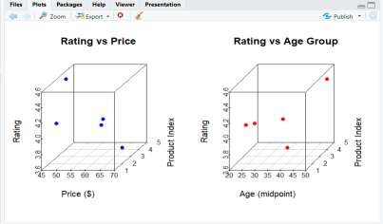
output:

- Environmental Data:

# Install required packages (run once) install.packages("plotly")

# Load library library(plotly)

# Dataset
data <- data.frame(
Location = c("A", "B", "C", "D", "E"),
Temperature = c(15, 20, 18, 12, 17),
Humidity = c(65, 70, 68, 60, 72),
CO2_Levels = c(400, 450, 420, 380, 430)
)

# 1. Check how CO2 varies with temperature and humidity print("Relationship between CO2 levels, Temperature, and Humidity:") print(cor(data$CO2_Levels, data$Temperature)) print(cor(data$CO2_Levels, data$Humidity))

# 2. 3D Scatter Plot scatter3d <- plot_ly( data,
x = ~Temperature,
y = ~Humidity,
z = ~CO2_Levels, type = "scatter3d",
mode = "markers+text", text = ~Location,
marker = list(size = 6, color = ~CO2_Levels, colorscale = "Viridis")
) %>%
layout(title = "3D Scatter Plot: CO2 vs Temperature and Humidity", scene = list(
xaxis = list(title = "Temperature (°C)"), yaxis = list(title = "Humidity (%)"), zaxis = list(title = "CO2 Levels (ppm)")
))
scatter3d
# 3. Spatial pattern (using same 3D scatter plot visually) # 4. 3D Surface Plot
surface_plot <- plot_ly(
x = ~data$Temperature,
y = ~data$Humidity,
z = ~data$CO2_Levels, type = "surface", colorscale = "Viridis"
) %>%
layout(title = "3D Surface Plot: CO2 Levels with Temperature and Humidity",

scene = list(
xaxis = list(title = "Temperature (°C)"), yaxis = list(title = "Humidity (%)"), zaxis = list(title = "CO2 Levels (ppm)")
))
surface_plot

# 5. Compare 3D plots separately # CO2 vs Temperature
plot1 <- plot_ly(
data, x = ~Temperature, y = ~CO2_Levels, type = "scatter3d", mode = "lines+markers", marker = list(color = 'red', size = 5)
) %>%
layout(title = "CO2 Levels vs Temperature", scene = list(
xaxis = list(title = "Temperature (°C)"), yaxis = list(title = "CO2 Levels (ppm)")
))

# CO2 vs Humidity plot2 <- plot_ly(
data, x = ~Humidity, y = ~CO2_Levels, type = "scatter3d", mode = "lines+markers", marker = list(color = 'blue', size = 5)
) %>%
layout(title = "CO2 Levels vs Humidity", scene = list(
xaxis = list(title = "Humidity (%)"), yaxis = list(title = "CO2 Levels (ppm)")
))

plot1 plot2

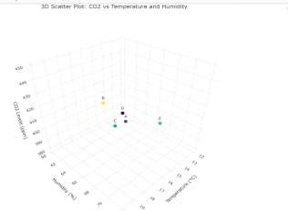
Output:

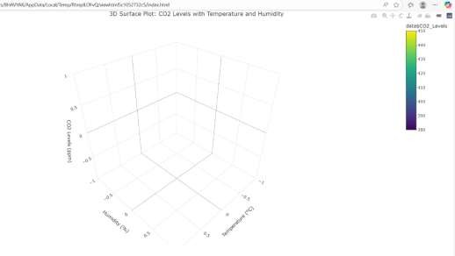
- Academic Performance Data library(plotly)
data <- data.frame(
Student = c("A", "B", "C", "D", "E"),
Math_Score = c(85, 72, 90, 78, 88),
Science_Score = c(78, 85, 80, 75, 82),
Attendance = c(95, 92, 98, 85, 93)
)

# 1. Check correlation between science score, math score, and attendance print("Correlation between Science, Math, and Attendance:") print(cor(data$Science_Score, data$Math_Score)) print(cor(data$Science_Score, data$Attendance))

# 2. 3D Scatter Plot scatter3d <- plot_ly( data,
x = ~Math_Score,
y = ~Attendance,
z = ~Science_Score, type = "scatter3d", mode = "markers+text", text = ~Student,
marker = list(size = 6, color = ~Science_Score, colorscale = "Viridis")
) %>%
layout(
title = "3D Scatter Plot: Science Score vs Math Score and Attendance", scene = list(
xaxis = list(title = "Math Score"), yaxis = list(title = "Attendance (%)"), zaxis = list(title = "Science Score")
)
)

scatter3d

# 4. 3D Surface Plot surface_plot <- plot_ly( x = ~data$Math_Score,
y = ~data$Attendance,
z = ~data$Science_Score, type = "surface", colorscale = "Viridis"
) %>%
layout(
title = "3D Surface Plot: Science Score with Math Score and Attendance", scene = list(
xaxis = list(title = "Math Score"), yaxis = list(title = "Attendance (%)"), zaxis = list(title = "Science Score")
)
)
surface_plot
# 5. Compare 3D plots separately # Science vs Math
plot1 <- plot_ly(
data,
x = ~Math_Score,
y = ~Science_Score, type = "scatter3d",
mode = "lines+markers",
marker = list(color = 'red', size = 5)
) %>%
layout(
title = "Science Score vs Math Score", scene = list(
xaxis = list(title = "Math Score"), yaxis = list(title = "Science Score")
)
)

# Science vs Attendance plot2 <- plot_ly(
data,
x = ~Attendance,
y = ~Science_Score, type = "scatter3d",
mode = "lines+markers",
marker = list(color = 'blue', size = 5)
) %>%
layout(
title = "Science Score vs Attendance", scene = list(

xaxis = list(title = "Attendance (%)"), yaxis = list(title = "Science Score")
)
)

plot1 plot2

Output:
